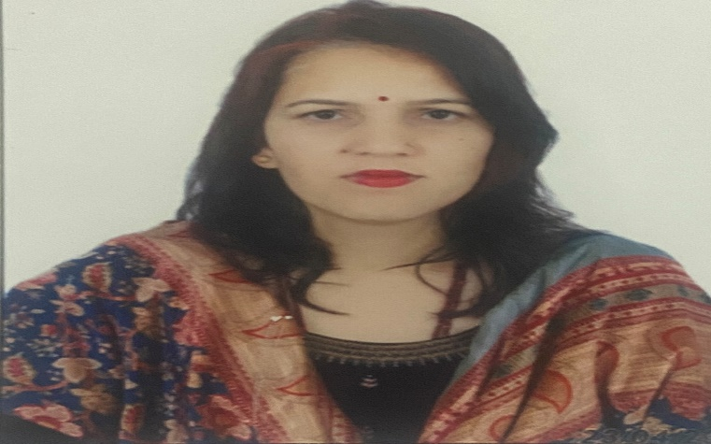
Mrs. Saroj
Assistant professor in Nimbus School of Education
Area
Primary Area: Education
Secondary Area: English

Contact
Email: sarojkhanna86@gmail.com
Phone: +91-7895249620

Education
- M.Ed. from H.N.B. Garhwal University.
- B.Ed. from H.N.B. Garhwal University.
- Post Graduate (M.A. English), Sri dev Suman University.

Teaching
- Education
- English

Academic Experience
Teacher, Blooming Public school may 2015 onwards
Teacher, Room to read, May 2018, onwards
Faculty Member, Uttaranchal college of Education, January 2022, onwards
Faculty Member, Nimbus School of Education, _________________onwards

Professional Experience
Nimbus School of Education
Nimbus Academy of Management

